MAHATMA GANDHI MISSION’S DENTAL COLLEGE & HOSPITAL
Accredited by NAAC with “A” Grade
Plot No. 1 & 2 Sector-01 (Old 18 & 19),
Kamothe, Navi Mumbai- 410209

E-Mail ID: mgmdch@mgmmumbai.ac.in

Umeed Inauguration Ceremony
Topic: Awareness On Animal Rights & Legalities
Organizing Department: Umeed Animal Welfare Club in association with CWC
Contributors: Mr.Vijay Rangare

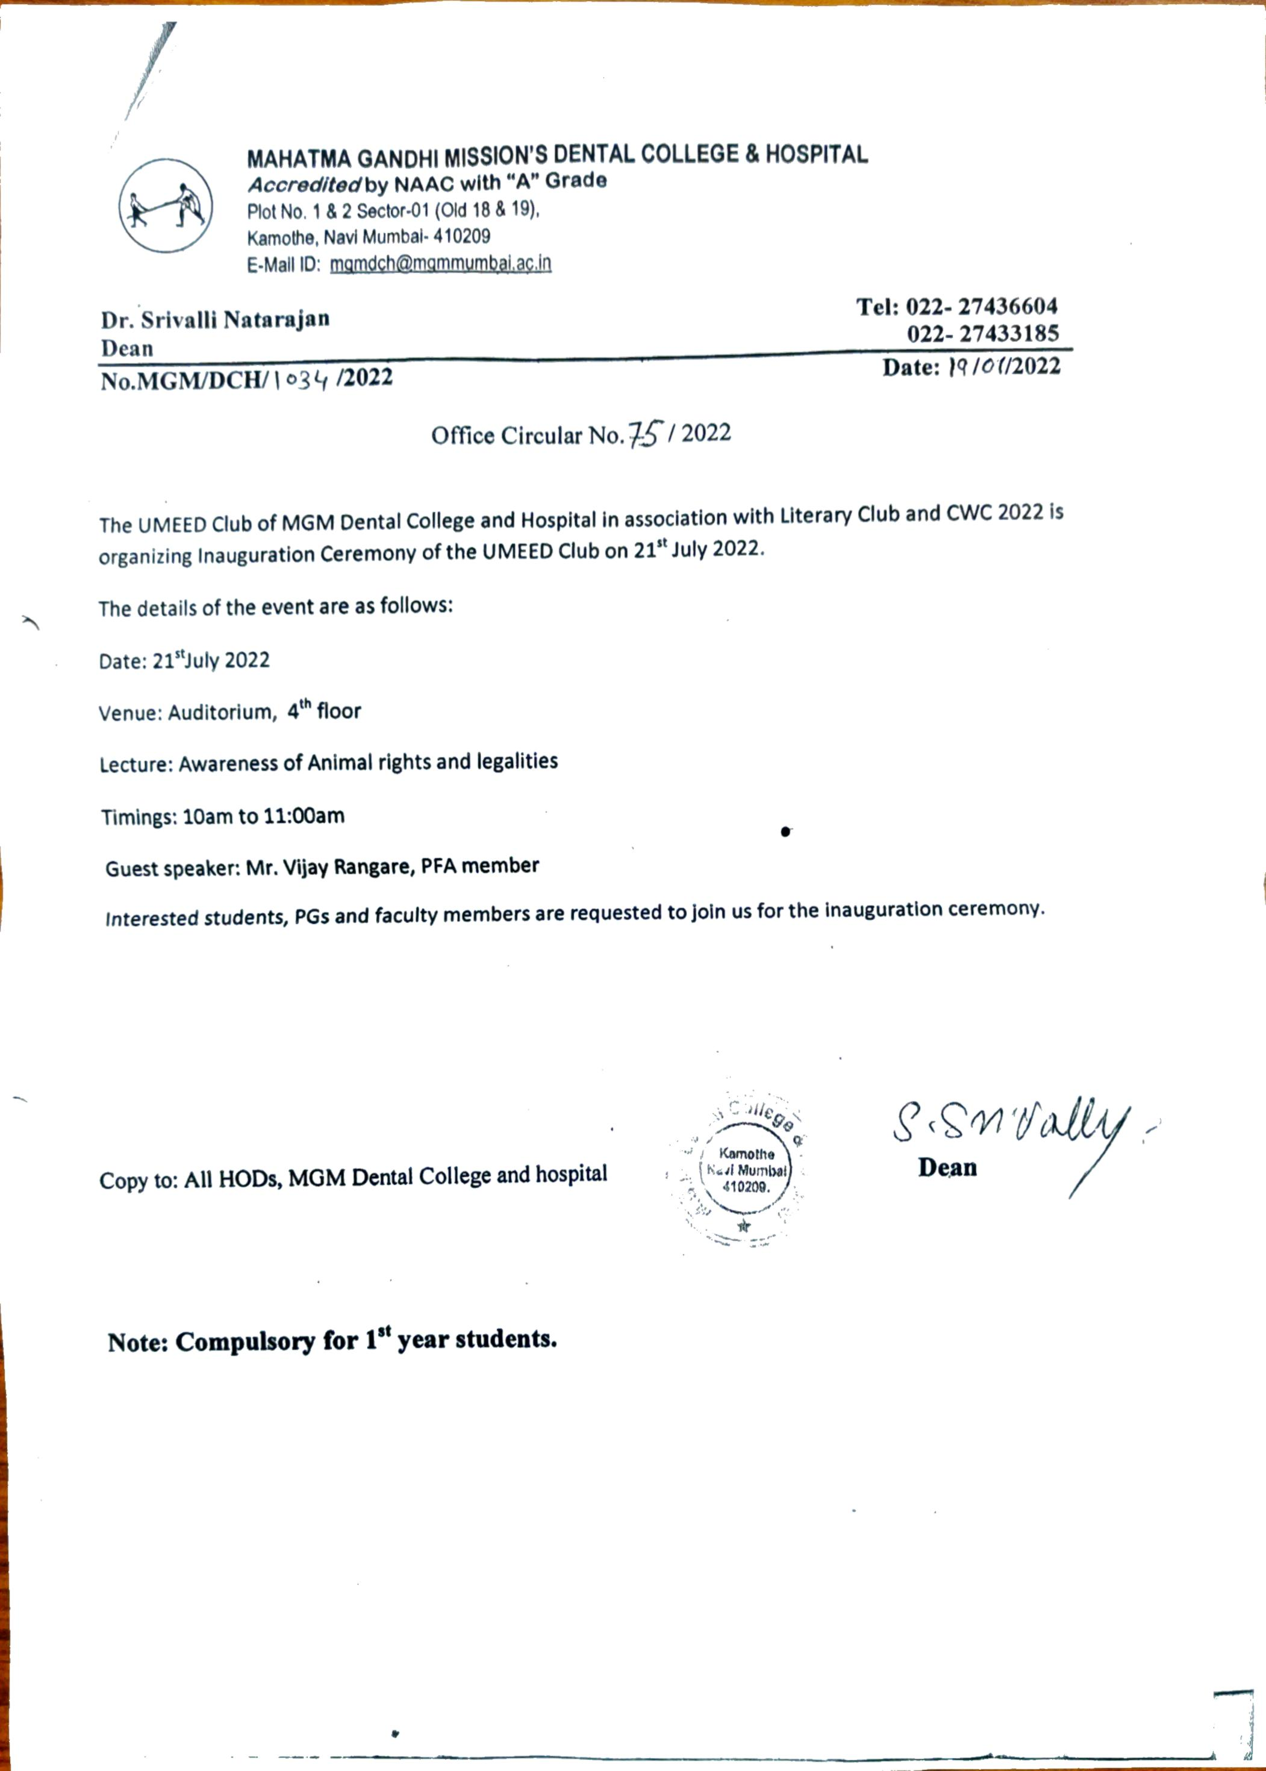
- Circular

- Brochure
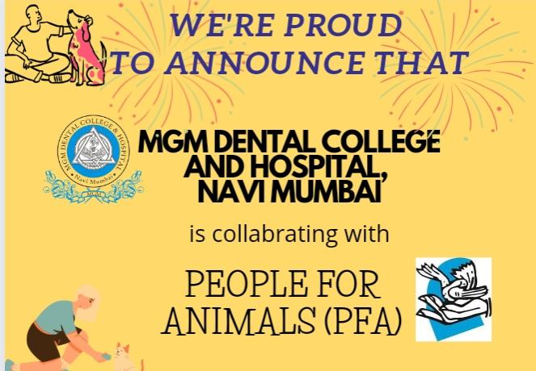
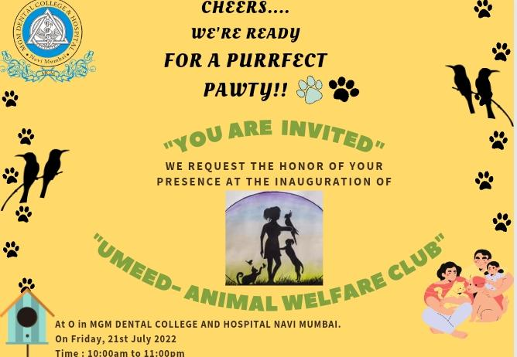

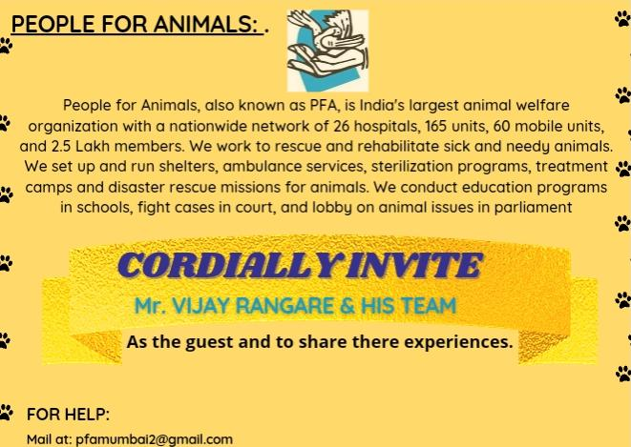

- Event Report:
The MGM Dental College and Hospital, Navi Mumbai hosted Umeed Animal Welfare Inauguration event on 21st July 2022 10 a.m. to 11 a.m. The events goal was to educate I BDS students & interns on animal rights and legalities as a society and a pet owner. Overall, we received overwhelmingly favorable response, with 100% of participants responding positively on the event to create awareness about the legalities and rights towards animals.
At the end of the event students will aware regrading Rights & legalities as a feeder.Rules against animal abusers. Legalities for domestication for pet owners. Rights for animals and our duty as a society.
The lecture was conducted by Mr. Vijay Rangare, president of PFA Navi Mumbai Panvel unit I. He made sure to make each and every attendees understand the importance of animal rights and their welfare. The program was concluded by placing the water bowls around the campus donated by Mr. Vijay Rangare to MGM dental college and hospital as a small step towards the right beginning.

- Photos:
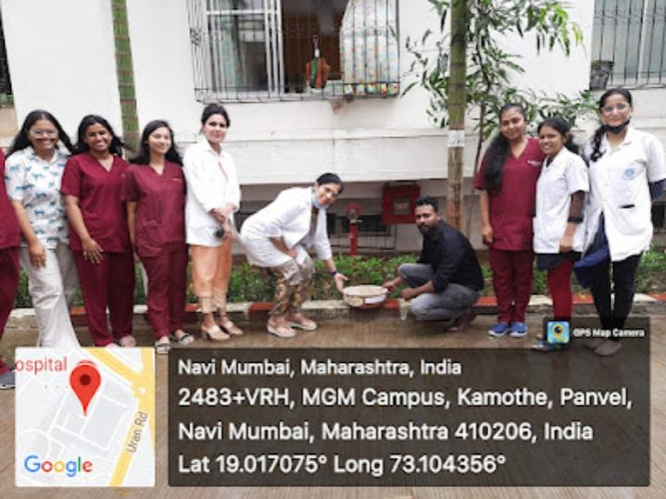
Mr. Vijay Rangare taking a lecture on animal rights and legalities.
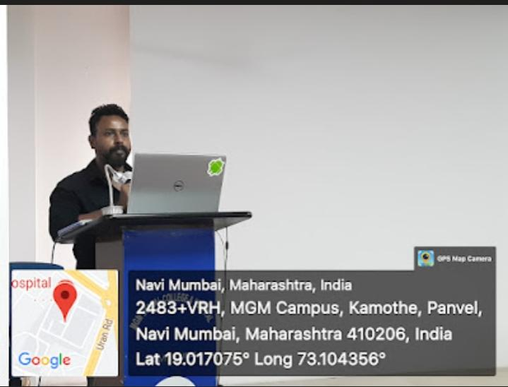
Bowl placement around the campus for strays.

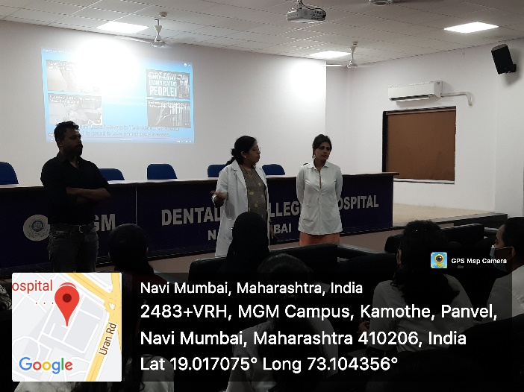
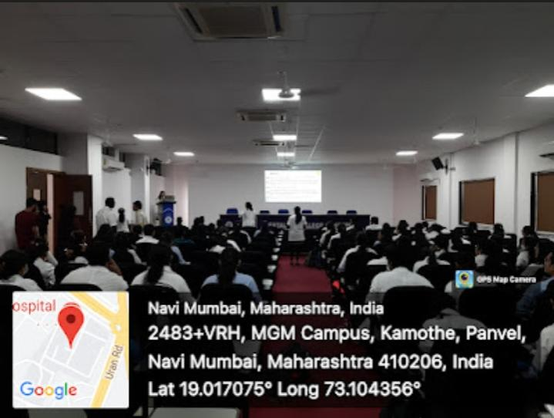
Inauguration program conducted in Auditorium.
Dean of MGM dental college explaining students about the importance of the rights of animals.

Attendance list:

Sr. No. | Name of the Student
 | Adakane Suyash Sanjay
 | Aiman Ayesha Khawaja Nizamuddin
 | Ansari Kazim Akhter Ansari Khaleel Ahmed
 | Anwar Nafees Nasim
 | Bhanushali Karishma Ajay
 | Borkar Kalyani Keshav
 | Chadha Jupneet Rajbir Singh
 | Chapherkar Khushi Mangesh
 | Chheda Tisha Mayur
 | Choudhary Aditi Anand
 | Dalvi Om Virendra
 | Dalvi Sanskruti Nitin
 | Desale Sutosh Pankaj
 | Dhanani Maitri Kapil
 | Dhewale Kalyani Sanjayrao
 | Doshi Krisha Pragnesh
 | Gaikwad Mrunmai Girish
 | Gajbhiye Sanchi Shashank
 | Gala Mitali Kalpesh
 | Game Saket Bhausaheb
 | Ghag Isha Prasanna
 | Gogate Nachiket Ashish
 | Gonnade Vaishnavi Pradeep
 | Gorde Thea Vijay
 | Gosavi Aditi Vivek
 | Gulabani Nirmita Maheshkumar
 | Ayesha Ayazuddin Sheerazi
 | Jadhav Aarti Rajendra
 | Jadhav Himanshu Pratap
 | Jadhav Rajlaxmi Sachin
 | Jain Aashna Nilesh
 | Jain Kinjal Dinesh
 | Jayakar Geetanjali Sudhir
 | Judit Thomas Koshy
 | Jyothika R
 | Kadam Aditi Sanjeev
 | Kambale Neha Shantaram
 | Kamodkar Tanmay Ashok
 | Katkar Gaurav Vijay
 | Khadkikar Gauri Shivkumar
 | Pinge Chaitanya Jaggu
 | Rahaf
 | Raje Sanjivanee Raju
 | Rathod Kirti Vishnu
 | Rathod Monica Bhaulal
 | Rizvi Mona Syed Hasan
 | Sanghvi Kajal Manoj
 | Sawtekar Aditi Nitin
 | Shah Gourav Nilesh
 | Shah Heena Dinesh
 | Shah Nehin Hitesh
 | Shetty Sirisha Nitin
 | Silveira Pearl Gregory
 | Surabhi Landge
 | Hodar Yashvi Sanjay
 | Honrao Rushikesh Sambhaji
 | Iyer Rahini Ramesh
 | Jadhav Rutuja Gulabrao
 | Jagtap Sritej Ramesh
 | Jain Mansi Manish
 | Jain Yaksha Pramod
 | Jaiswal Rutuja Raghuvir
 | Janhavi Shrivastava
 | Arpita Biswas

